WEB TECHNOLOGY PROJECT

ONLINE BOOK STORE

COST ESTIMATION

Submitted by,

2018506051 – Kaviya. N

2018506058 – Losshika. S. N

2018506077 – Poovithal. Rama

ONLINE BOOK STORE

*COST ESTIMATION*

**COST ESTIMATION:**

Cost estimation in project management is the process of forecasting the cost and other resources needed to complete a project within a defined scope. Cost estimation accounts for each element required for the project and calculates a total amount that determines a project’s budget.

Here, we have done cost estimation by Bottom up estimation technique. This technique involves the aggregation of individual estimates for each work item in the Online Book Store till the project gets over.

In the relatively simple project of trekking, a certain level of holistic thinking is required. Without holistic thinking, projects will be hit by unidentified risks.  The unforeseen risks lead to additional costs that are never a part of the budget. Hence having a financial buffer cannot compensate.

**LIFECYCLE OF THE PROJECT:**

From a project cost perspective, not using holistic thinking can lead to some rather costly consequences. We have identified all possibilities of the project and drawn the life cycle of the project which will be very useful in estimating the cost of the project.

HOME PAGE CREATION

* Admin page creation
* Register (signup) page creation
* User login page creation

LOGIN AS ADMIN

* Enter details
* Check whether registered admin
* Go to admin page
* Select available options

REGISTER

* Enter details
* Validate details
* Add to DB

LOGIN AS USER

* Enter details
* Check whether registered user
* Go to user page
* Search and add books to cart
* Go to cart page
* Add and delete books to cart
* Proceed order
* Payment
* Order confirmation

This life cycle is framed using one of the cost estimation tools called ‘GANTTPRO’ which itself calculates the cost based on the work of each module.

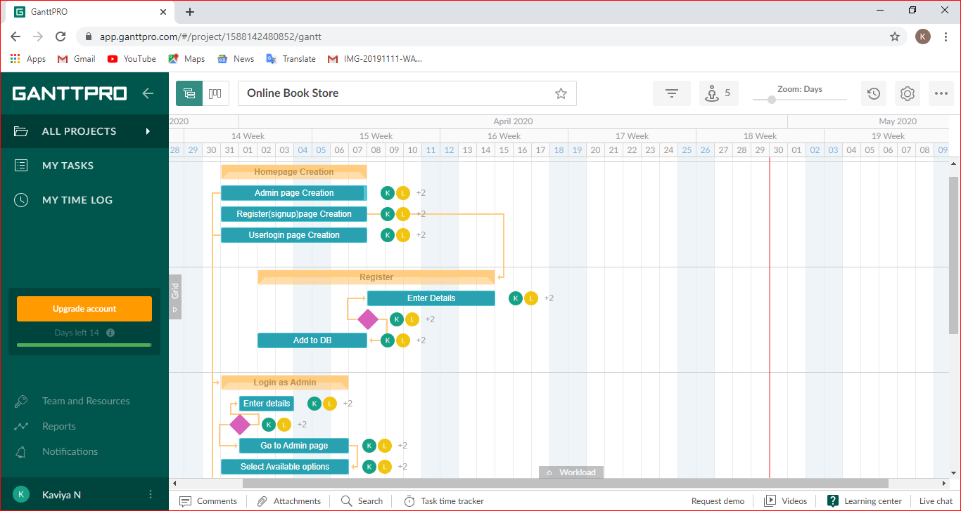

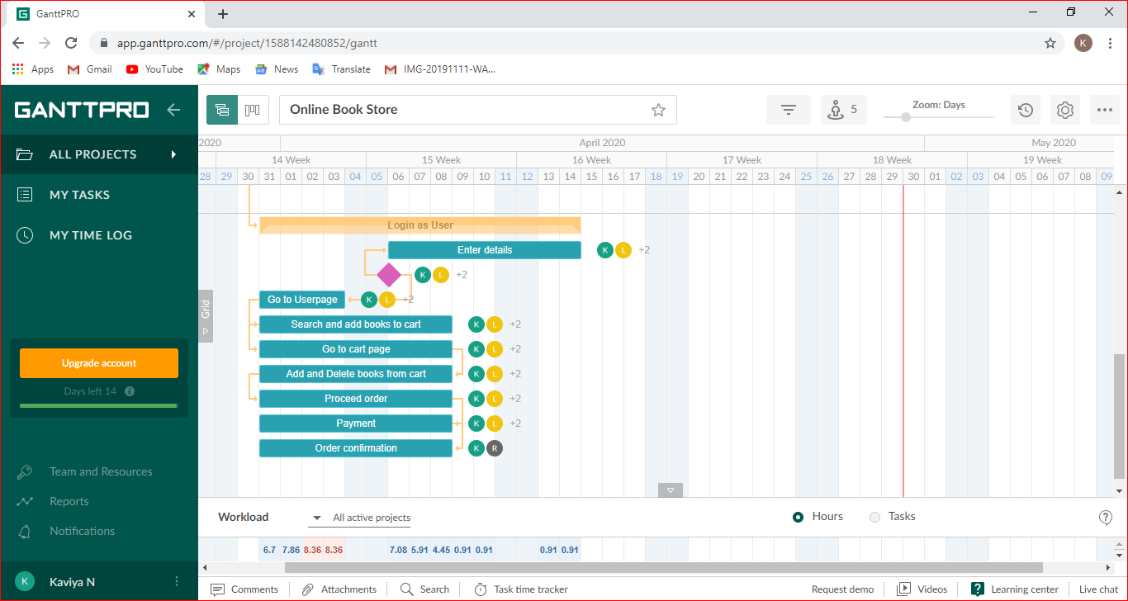

**BUDGET ANALYSIS:**

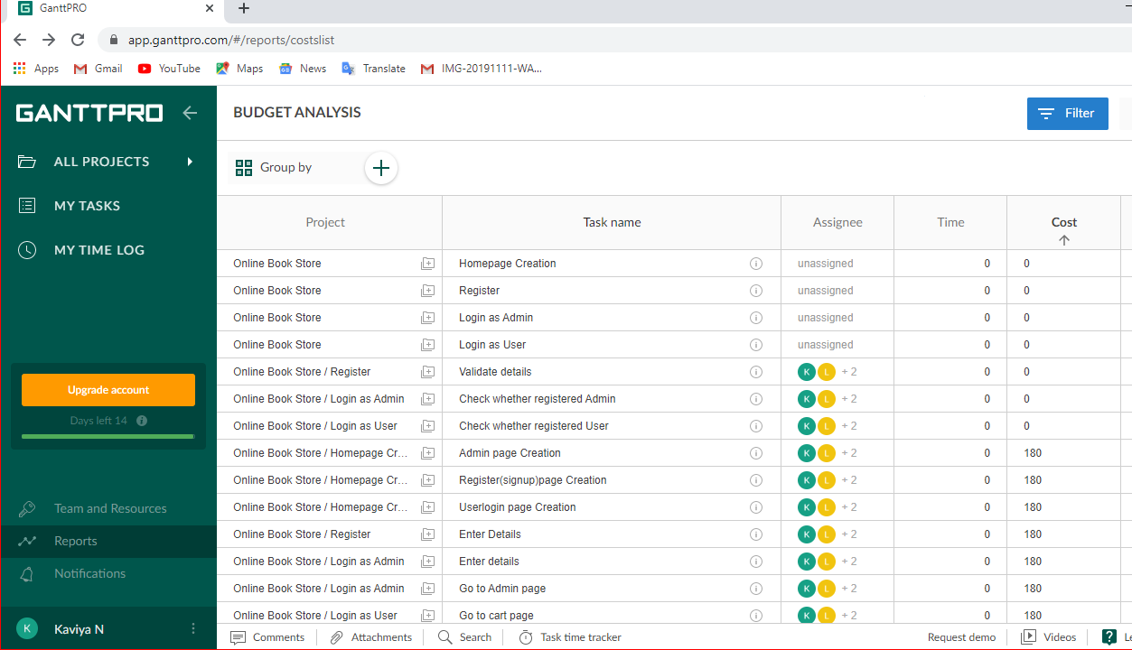

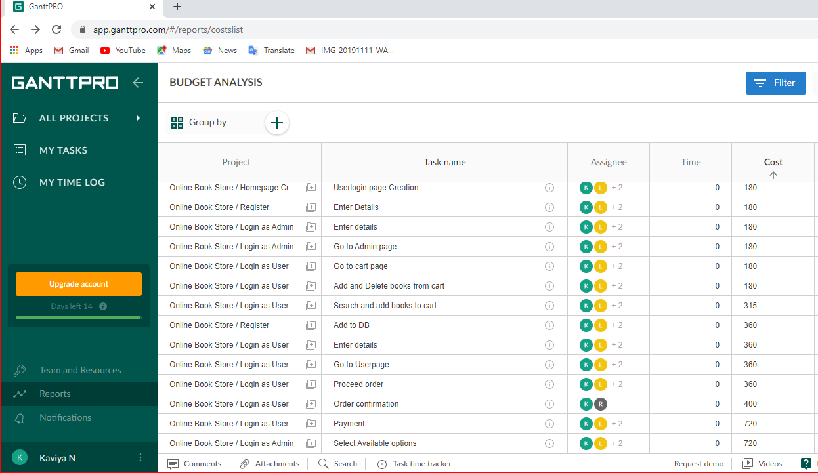

**COST ESTIMATION:**

According the lifecycle of the project and the way it undergoes the application,

Estimated cost = 5035

Estimated hours = 115h

Individually, each module cost are also listed.

|  |  |  |
| --- | --- | --- |
| **TASK NAME** | **ESTIMATED**  **HOURS** | **ESTIMATED COST** |
| HOME PAGE CREATION | 12h | 540 |
| * Admin page creation | 4h | 180 |
| * Register (signup) page creation | 4h | 180 |
| * User login page creation | 4h | 180 |
| LOGIN AS ADMIN | 24h | 1080 |
| * Enter details | 4h | 180 |
| * Check whether registered admin |  | 0 |
| * Go to Admin page | 4h | 180 |
| * Select available options | 16h | 720 |
| REGISTER | 12h | 540 |
| * Enter details | 4h | 180 |
| * Validate details |  | 0 |
| * Add to DB | 8h | 360 |
| LOGIN AS USER | 67h | 2875 |
| * Enter details | 8h | 360 |
| * Check whether registered user |  | 0 |
| * Go to User page | 8h | 360 |
| * Search and add books to cart | 7h | 315 |
| * Go to cart page | 4h | 180 |
| * Add and delete books to cart | 4h | 180 |
| * Proceed order | 8h | 360 |
| * Payment | 16h | 720 |
| * Order confirmation | 12h | 400 |
| **TOTAL** | **115h** | **5035** |

